SQL ASSIGNMENT -13

ROLL NO-84016

Q1 create a union of two queries that shows the names,cities, and ratings of all customers. Those with rating of 200 or greater will also have the words “high rating”, while the others will have the words “low rating”
Ans.
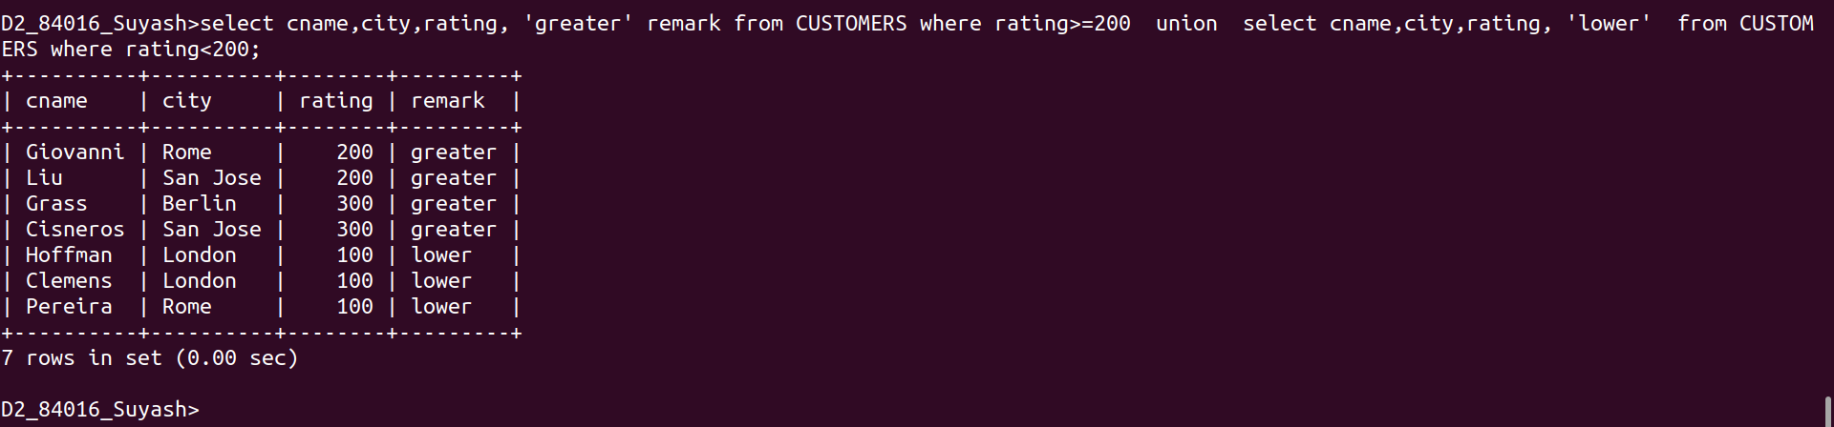

Q2.Write a command that produces the name and number of salesperson and each customer with more than one current order. Put the results in alphabetical order.
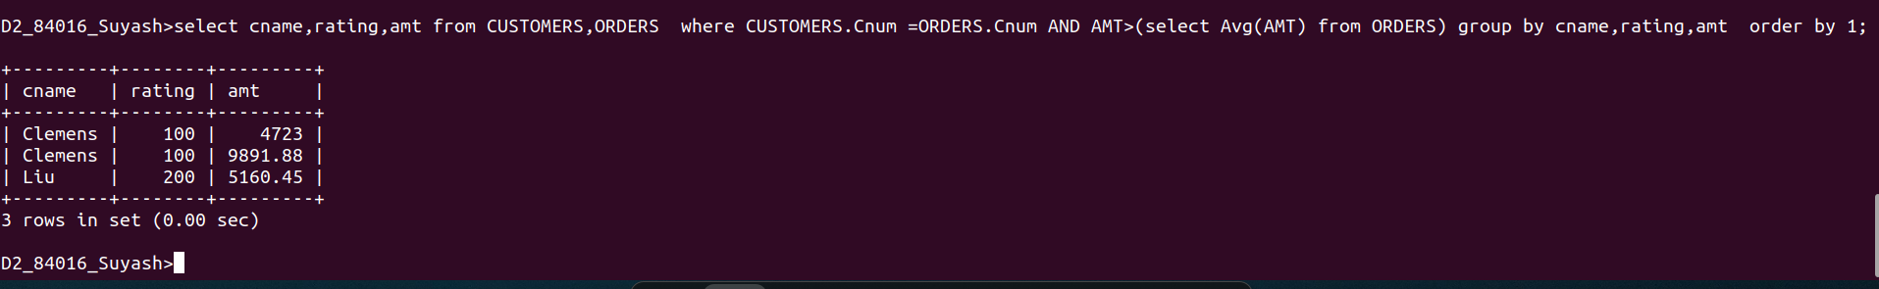

Q3.Write a query that selects the total amount in orders for each salesperson for whom this total is greater than the amount of the largest order in the table.
Ans.
